SCREENPLAY, SCRIPT WRITING AND STORY BOARDING ?
IN FILM MAKING

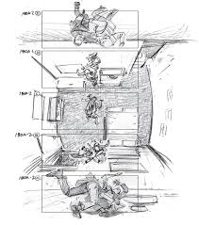
DEPARTMENT OF MASS COMMUNICATION
LAHORE COLLEGE FOR WOMEN UNIVERSIT

WHAT IS SCREENPLAY ?
A screenplay, or script, is some kind of written work by screenwriters for a film, television program, or video game. These screenplays can be original works or adaptations from existing pieces of writing. In them, the movement, actions, expression and dialogues of the characters are also narrated.
to write a screenplay that go something like this:
• Immerse yourself in film script writing theory.
• Write visually.
• Keep lots of white space on the page.
• Write, write, write, every day.
• Understand that writing is rewriting.

Understanding how to write a movie script, also known as a screenplay, can seem daunting at first, but once you understand script format and structure you can then focus on your creativity.

We’ll take you through the process of writing a screenplay so that you can begin building that great movie idea into a professional script.

WHAT IS A SCREENPLAY

A movie script, also known as a screenplay is a document that ranges anywhere from 70-180 pages. Most movie scripts come in around 110 pages, but there are a number of factors that play into the length.

Before we go too deep into page count, let’s talk about the things you really need to know so that you can get started on your script ASAP.

HOW TO FORMAT A SCREENPLAY
What is standard screenplay format?

Screenplay format is relatively simple, but it’s one of those things that can seem a bit daunting until you’ve actually learned how to do it.
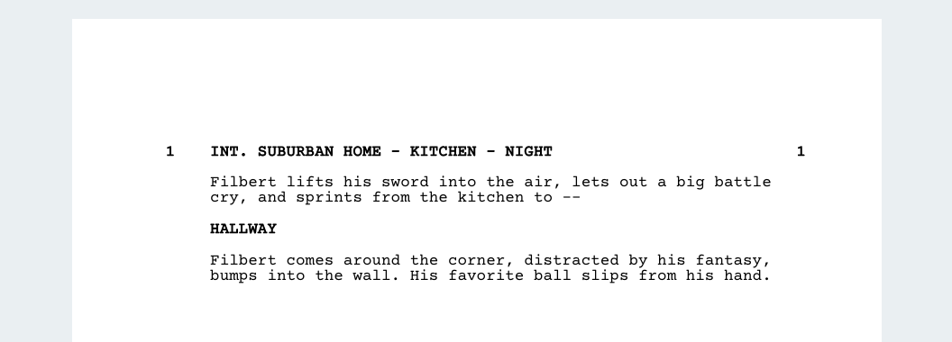

The basics of script formatting are as follows:

12-point Courier font size
1.5 inch margin on the left of the page
1 inch margin on the right of the page
1 inch on the of the top and bottom of the page
Each page should have approximately 55 lines
The dialogue block starts 2.5 inches from the left side of the page
Character names must have uppercase letters and be positioned starting 3.7 inches from the left side of the page
Page numbers are positioned in the top right corner with a 0.5 inch margin from the top of the page. The first page shall not be numbered, and each number is followed by a period.
StudioBinder screenwriting software does all the required formating, so you can focus on the creative. Below is a formatted script example:

Many scripts begin with a transition, which may include FADE IN: or BLACK SCREEN. Some place this in the top left, others in the top right of the page where many transitions live. Other scripts will begin with scene headings, or even subheadings of imagery they want to front load.

SCENE HEADING

The scene heading is there to help break up physical spaces and give the reader and production team an idea of the story’s geography.

You will either choose INT. for interior spaces or EXT. for exterior spaces. Then a description of the setting, and then the time of day.

Here’s a screenplay example:

how to write a movie script - afraid of the dark - studiobinder screenwriting feature - scene heading
Script format example in StudioBinder Screenplay Writing Software: Scene Heading
There are rare cases where the scene begins inside and goes outside, or vice versa, and in these situations you may write INT/EXT. or EXT/INT.

Some scripts take place all around the world, so often screenwriters will use multiple hyphens to give the scene headings even more detail:

how to write a movie script - afraid of the dark - studiobinder screenwriting feature - character intro - double hyphen scene heading
Screenplay format example in StudioBinder Screenwriting App: Scene Heading Details
This helps the screenwriter avoid having to point out the geographical location in the action lines, saving space to write more about the actual story and keep readers engaged in the story… not the formatting.

SUBHEADING

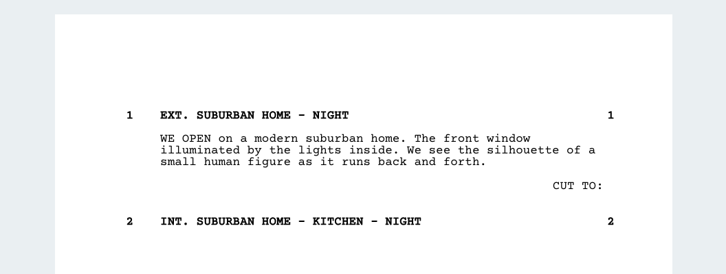
Often, writers will use subheadings to show a change in location without breaking the scene, even if the scene has shifted from INT. to EXT.

Here’s a script example:
how to write a movie script - afraid of the dark - studiobinder screenwriting feature - subheading
Script formatting example in StudioBinder Sciptwriting Software: Scene Subheading
It is assumed that readers will understand the change in space while retaining the idea that the time of day is the same - even continuous.

The reason many writers do this is to avoid the notion that we’ve entered an entirely new scene, though you could always include CONTINUOUS in place of DAY or NIGHT by creating an entirely new scene heading.

It’s a matter of personal style and rhythm vs. production considerations.

TRANSITIONS

In the bottom right of the page you will place transitions, but in modern screenwriting these seem to be used less and less. The transitions that seems to have really stood the test of time are CUT TO: and FADE OUT.

Here’s a screenplay example:
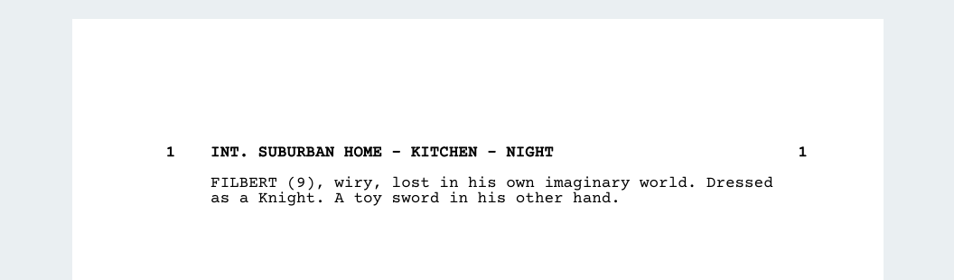

how to write a movie script - afraid of the dark - studiobinder screenwriting feature - transition
Screenplay formatting example in StudioBinder Sciptwriting Software: Scene Transition
You may also include something like DISSOLVE TO:, but these are used less and less, probably for the same reason you avoid camera shots.

CHARACTER INTRODUCTIONS

When you introduce a character in a screenplay, you want to use all-capital letters for the name of the character, then a reference to their age, and finally some information about their traits and personality.

how to write a movie script - afraid of the dark - studiobinder screenwriting feature - character intro - double hyphen scene heading (1)
Script format example in StudioBinder Scriptwriting Software: Character Introduction
Again, screenwriters have found other ways to do this, but this is the most common and production friendly way to introduce a character.

We have a post on how to introduce characters in a screenplay that goes into the creative considerations of introducing characters, so I highly recommend you check it out after this post to learn more.

ACTION

Action lines are where you describe the visual and audible actions that take place on screen. You want to write in third person in present tense.

how to write a movie script - afraid of the dark - studiobinder screenwriting feature - action
Script format example in StudioBinder Screenwriting Solution: Action Lines
Often, you can make your script a better read by eliminating redundant pronouns and conjunctions. Big sounds and important objects can be written out in ALL CAPS to emphasize their effect on the story.

DIALOGUE

Your lines of dialogue will be set underneath the character to which they are assigned. Dialogue is pretty straightforward from a formatting standpoint, but it is the most difficult part of screenwriting.

how to write a movie script - afraid of the dark - studiobinder screenwriting feature - dialogue
Script format example in StudioBinder Free Screenwriting App: Dialogue Lines
If you want to learn more, check out our post on 22 Screenwriting Tips for Writing Better Dialogue where I go over a bunch of ways to audit your screenplay for good… and bad dialogue.

EXTENSIONS

These occur when a character says something off-screen (O.S.), or if dialogue is voice-over (V.O.). You will see extensions when a character ends a block of dialogue, performs an action, and speaks more.

how to write a movie script - afraid of the dark - studiobinder screenwriting feature - extension
Screenplay format example in StudioBinder Web-Based Scriptwriting Software: Extensions
This takes the form of continued (CONT’D). Professional script writing software will help you with this, but it will not be able to predict when you want something said off screen or in voice-over.

PARENTHETICAL

You can use a parenthetical inside your dialogue to show small actions, or even a change in mood without having to jump out to an action line.

how to write a movie script - afraid of the dark - studiobinder screenwriting feature - parenthetical
Script format example in StudioBinder Free Script Writing Software: Parenthetical
Parentheticals are really good for directing actors, and adding sarcasm and nuance to performances on the page, but you may want to be cautious about adding them too much. Actors are professionals, and if Al Pacino finds parentheticals in a script, he may get his feelings hurt.

CAMERA SHOTS

The best professional screenwriters know how to suggest shots without actually writing in shots, but if you really insist on describing a particular shot in your screenplay you can format it like a subheading.

how to write a movie script - afraid of the dark - studiobinder screenwriting feature - camera shot
Script format example in StudioBinder Online Screenwriting Software: Camera Shot
This lets us know that the shot is supposed to be set so that we see things from Filbert’s perspective. Writing out shots is often frowned upon, but if you’re directing the film, maybe do it sparingly.

HOW TO WRITE A MOVIE SCRIPT
Use proper script font & margins

The screenplay font used to write movie scripts is Courier 12pt.

Courier is used as the standard screenplay font because it creates a page to screen ratio of 1:1. Where one page of a script translates to one minute of screen time, so this is one area that really shouldn’t be modified.

Page margins for a professional movie script are 1” for the top, bottom, and right side margins. The left margin is 1.5” for punch hole space.

StudioBinder provides a completely FREE and unlimited screenwriting software, so you don’t have to be worried about script fonts and margins.

StudioBinder's FREE Screenwriting Software
Because StudioBinder is cloud-based, you will be able to access your securely saved screenplay from any computer in the world. Our software helps you properly format, create versions, and automatically syncs to a number integrated production planning features.

Technology is there to make our lives easier, though I applaud you for having an interest in learning about professional screenplay font.

If there ever comes a time where screenwriting software is completely eliminated due to some sort of cataclysmic event, I think we’ll all have bigger concerns than understanding how to write a movie screenplay.

Now… let’s talk screenplay page count.

WHAT IS SCREENPLAY FORMAT
Consider your page count

How long should your movie script be?

It’s a difficult question because comedy scripts generally come in somewhere around 90 pages (1 hour + 30 mins) while action and drama scripts come in around 110 (1 hour + 50 mins).

It’s harmful to worry about this too much because what you really need is a script that is lean, mean, and compelling at every turn.

If you think your script is a bit thin, you may need to add a bit more, but every page you add means more money needed to produce the film.

If you write a great 80 page script, you may just have a screenplay that will both excite production teams, but also viewers with small bladders.

WHAT IS A SCRIPT
Plan out script beats & story structure

Story structure is a much more difficult topic to nail down when compared to formatting, so buckle up. Many screenwriter, directors, and viewers find that classic story structure leads to formulaic moviemaking.

It totally does… and that’s why many movies are xeroxes of xeroxes.

So why is this still the best way to have your screenplay produced as well as a really helpful tool for writing your screenplays?

Production companies, studios, producers, and executives have poured years, and maybe even decades into learning the business of feature films, and the vast majority have used classic story structure.

Do screenwriters and directors all follow it perfectly? — No.

Do screenwriters and directors all understand structure? — Yes.

You have the Save The Cat Beat Sheet, Three Act Structure, The Hero's Journey, The Story Circle — all of these are ways to make that great idea you have become a coherent story that emulates the human experience.

We all have highs, and we all have lows.

The true benefit of story structure is that it gives you a plan to build so that when you sit down to write you don’t just stare at the blank page.

It’s just a navigation map for your big roadtrip… one that producers and studios will want you to have so they can bank on your screenplay.

One of the non-negotiable support documents you want to create is a screenplay outline. This is where you can create your own roadmap, with all of the considerations you personally care about for your script.

Script outlines often present the scene page count, overall story beats, and the relationship each scene has with the other scenes in your script. If you’re trying to overcome writer’s block, a script outline will keep you focused and help you write your story.

HOW TO WRITE A SCREENPLAY
How long does it take to write a screenplay?

Many are curious how long it should take a screenwriter to write a movie script, and while it will always depend on a personal schedule you will be best served by setting up a rigid, professional writing schedule.

When professional screenwriters are given time to write a screenplay, they’re provided a time range between 1-3 months (30-90 days).

In the past, I’ve set my personal writing pace at 6-7 pages in an 8 hour day of writing, which roughly translates to about 15 days of writing.

If you’re truly focused on your script, planning out the structure, theme, characters, setting, and plot may take you a couple of weeks.

The short answer is that it should take around a month.

Some screenplays I wrote took 6 months… others took 2 weeks.

The time shrinks with each screenplay because you become more and more familiar with the overall process like any other craft or job.

Your inspiration and creative energy will only grow when you work on your projects and scripts, and it will only shrink when you don’t.

MOVIE SCRIPT WRITING
Make a screenplay title page

The next step is to create your title page for your screenplay. This is a somewhat interesting, albeit brief topic of discussion. Part of this comes from the fact that screenwriter used to add personal info on the page.

This is still totally fine, but there are much better ways to make sure potentially interested parties have a way to contact you about your story that doesn’t require you to include your home address.

You shouldn’t be scared to put yourself and your work out there, but you should use technology to give yourself a smoother process like adding an email address designated to your writing so that personal emails don’t get mixed up with important screenwriting emails.

SAMPLE SCRIPT
Other important screenwriting notes

There are some nuanced screenwriting practices that may seem correct, but can actually confuse or hinder the physical production.

One example is your time of day in your scene heading.

Professional screenplay software will give you about a half dozen options including MORNING and SUNSET. This is an ironic moment where screenwriters actually hurt productions with proper formatting.

These should generally be avoided unless the time of day is absolutely integral to the story because your script will import into production planning software and create stripboards that instruct the production to schedule the actual shoot times during a very small window of time.

Most morning and sunset scenes are filmed whenever and however a director and production team can figure out because planning your entire day of filming around 1-2 hours of available light is a great way to lose a lot of time, money, morale, and built up trust.

Even if you have a character who wakes up late for work, you really won’t need to use MORNING because that scene will most likely be filmed during the day, or may even be filmed on a soundstage with artificial lighting. What about the rules with action lines?

Screenwriters like Quentin Tarantino will sometimes include character motivations or aspects of the film that will not be shown on screen. Generally, this practice is frowned upon in screenwriting.

But he’s Tarantino… right?

The reason you don’t want to go too crazy with this is because it becomes a slippery slope where novice writers default to adding information the viewer can’t see or hear to the screenplay to give padding and context.

The truth is that writers should focus on building things we all get to see on screen, and not focus on motivation that isn’t apparent on screen. That’s also generally what character breakdowns are for, which you can include with your screenplay to producers, directors, and the actors.

You generally understand script formatting, but after reading a number of popular movie scripts you’ve actually become more confused.

When you read movie scripts and screenplays you quickly learn that many screenwriters play fast and loose even with script writing format, however, they all get pretty close and predominantly use their somewhat liberal interpretation of script writing format to help readers visualize the scenes in a way that keeps a good pace, flow, and rhythm.

Difference between screenplay and script
The main difference between the terms script and screen play (or screenplay as one word) is that typically people think of a script as for theater whereas a screenplay is clearly for the film industry. However, since a script can also be a screen play, it is interchangeable in that way.

SCRIPT & STORYBOARD
INTRODUCTION

Once a basic story structure has been created, the next step is to write the script and create the storyboard. These next stages allow for detailed planning of the film, from action and dialogue to sets and camera setups. A basic rule of thumb for script and storyboard is to ask ‘what is this contributing to the story?’ for every decision made. All too often action and dialogue is superfluous to the story and reduces the quality of the finished film.
Script
There are a number of conventions in scriptwriting which help to organise the film making process, making it easier to recognize locations required, characters in each scene and set design requirements. In a classroom setting, there is no need to adhere to strict script writing conventions, but some guidelines will make the process easier at production stage.

⎯ The person who writes the script for a film is called the screenwriter.
⎯ Film actors learn their lines from a script or screenplay text.
⎯ A director uses the screenplay to help plan how the film will be made.
⎯ Each screenplay consists of scenes. A scene is where the action of the
story takes place.
⎯ Each scene includes a description, details of characters’ actions, and
details of the location.
⎯ Actions are given whenever anything physical happens, for example,
“Mary walks towards the door.”
The Script
A script is made up of a series of scenes. The number of scenes will depend on the length and content of your film. As a rule, each scene should have an action or a main message that develops the story or the overall message of the film, and each scene takes place in a specific location.
The script includes detailed information on the aural and visual aspects of your film, or, in other words, everything that is said and seen in your film. Everything that is said is the dialogue. When writing your script, think about the content and delivery of your dialogue. Who is talking? What do they need to say? You may also consider using voiceovers. A voiceover(VO) is when a character/person’s voice is heard ‘over the top’ of a scene. Remember to include information about any sounds you require in your film.
Your script also needs to detail what we see. Where is the
steps to writing a movie script:
Here’s a short (non-exhaustive) list of some of the first steps to writing a script you should take.
6 steps to laying the foundation.
1. The first step is to commit to screenwriting. You’re not going to get very far if you don’t take it seriously and are prepared to put in the work. This post lays out how to become a screenwriter by committing to the craft.
2. Writing a good script means reading great screenplays. Download and read as many as possible. Our list of 50 of the best screenplays to read is a great starting point.
3. Read the best screenwriting books out there in order to acquaint yourself with as many film script writing theories as possible.
4. Make a list of twenty movies you wish you’d written and rewatch them. Make notes on why you love certain scenes, pieces of dialogue, characters, etc. as you go. Immerse yourself in the classics of cinema by watching movies on some “best movies of all time” lists.
5. Writing a script outline of a movie as you watch it and then breaking it down, is an essential part of learning how to write a movie script. If you want to learn how to do it, grab a copy of our free Structure Hack pdf.
6. If you haven’t already, purchase some professional screenwriting software and master the basics of how to format a script.

Development of script

⎯ Discuss how information is presented in a script: e.g. is it written in the present tense? (here and now), visualize it and describe what the characters do.
⎯ List the actions that are included in the descriptions, for example, “Students are talking away and working in the classroom,” or “Sam has a look of horror on her face; she puts her hand to her chin.”
⎯ Name all the characters – for example; Sam, Aoife, Sam’s mother (Mrs Maguire), the receptionist, the dentist, the teacher, etc.
⎯ Where does the story take place? In a house, a school corridor, a stairs, dental surgery, in a kitchen, i.e. will it be shot in an interior or exterior location.
Scripts for Businesses
location(s) of your film? What action is taking
place? This information needs to be included in your script.
· Break down the script into key scenes (What is the action/message of each scene?)
· Focus on the aural and visual elements of your film (What is said? What is seen?)
A few things you need to know — Scriptwriting
Conventions. Put page numbers in the top right-hand corner. Use a standard margin of 2.5 cm at the top, bottom and right of the page. If it is a bound script, have a 3.9 cm margin on the left-hand side. Put your scene heading (or ‘slugline’) in capital letters in the middle of the page. A scene heading shows the time of day and location.
For example,
THE BOARDROOM.MIDDAY
Put action lines below the scene heading. An action line gives a description of action and events taking place. Action lines are written in present tense. The first time a character/person’s name is read, it should be in capital letters.
AMANDA walks in the boardroom. She is laughing.
Note you can familiarise yourself with scriptwriting conventions and formatting by reading other scripts. Once you have written your script, reread for typos.
The Shooting Script
The shooting script is essentially information for the production crew (e.g. the director, the cinematographer). It works alongside the script to provide practical visual information about the duration of shots, type of shots, camera angles and camera movements.

It is usually presented in a table format and includes the scene, the shot, the description of the shot and sound. Note that a shot is what the camera takes from when it starts recording to when it stops recording. A scene is usually made up of a series of shots.
Sound is also an important part of your shooting script, include information about sounds that are included in the shots (e.g. Is there a voiceover or a mobile phone ringing in the shot?)
· Remember, the shooting script is practical information for the production crew.
A few things you need to know — Useful Terms for Shooting the Script
Close up (CU)
Mid Shot (MS) Wide Shot (LS)
A close up focuses on a character/person’s face. It may also focus on an important object
A mid shot focuses on the character/person from the waist up.
A wide shot (or long shot) focuses on the person or the important object in a location

Point of View Shot A point of view shot is where the shot is taken
(POV)
from the visual perspective (the point of view) of the character
Reverse Shot (RS) A reverse shot is where the shot is taken from the opposite point of view of the point of view
shot. For example, if you were filming an interview and you has a point of view shot from the interviewer’s perspective, the reverse shot would interviewee’s perspective.
Camera Angles The camera angle is where the camera is positioned in relation to the action. You could
have a High Camera Angle (HCA), Low Camera Angle (LCA) or Eye Level angle (EL).
Camera Movement Zoom, pan and tilt are descriptive terms you can use to describe camera movement
The Storyboard
The Storyboard consists of drawings which show what the key shots will look like in your film, and how the shots and scenes will flow on from each other. The drawings can be simple, like a comic strip version of your film.
· The Storyboard comes from, and works alongside, your script and shooting script and demonstrates the ‘feel’ or atmosphere of your film.

What is a storyboard?

A storyboard is a visual representation of a film sequence and breaks down the action into individual panels. It is a series of ordered drawings, with camera direction, dialogue, or other pertinent details. It sketches out how a video will unfold, shot by shot.

It's is similar to a trial-run for your finished film, video, or commercial, laid out in a comic book-like form.

What's a Storyboard?
Drawings, sketches, reference images or photographs to represent each frame.
A description of the shot — any relevant information on the action, dialogue, or composition.
Shot specs — shot size, lens length, two-shot, etc.
Arrows to indicate camera and/or character movement or how each shot connects to the next

Alfred Hitchcock was notorious for his 'boards' — precisely crafting the movie in his head and on the page. He was so detailed, in fact, that actually shooting the film was boring.

All the interesting work had already been done.

Does this mean that you have to be as precise as Hitchcock? Absolutely not. Storyboarding is a tool that filmmakers bring into their process but everyone is different. In reality, defining "what is a storyboard" is actually up to the individual and what they make of it.

We'll begin with a quick storyboard definition before jumping into some storyboard examples and video interviews with filmmakers on their individual approaches for how to make a storyboard.

It's one thing to define storyboards — but what does a storyboard look like? From simple stick figures to detailed sketches, the quality or content of each panel is really a secondary concern as long as the board serves its purpose for the filmmakers.

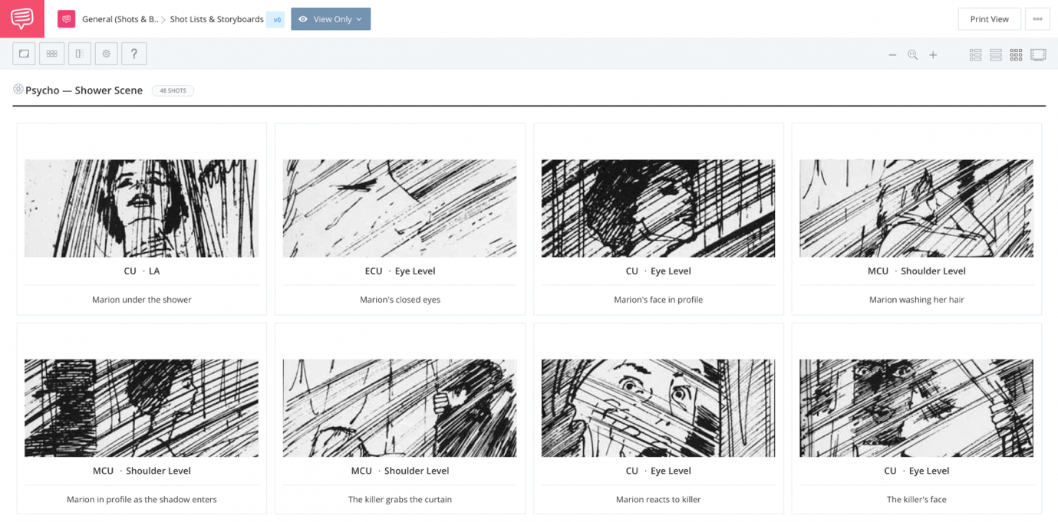

STORYBOARD FORMAT AND LAYOUT
Traditional vs. thumbnail

Storyboards can contain as much information as you want. Again, this is a tool to help you with the pre-production process so don't feel completely tied to one storyboard format over another.

There are two basic versions of storyboard format: traditional and thumbnail. In short, the difference between these two layouts comes down to how much detail you include.

Traditional storyboards are what we see above — basic pencil sketches that include detailed information like arrows for camera movement, characters, props, etc.

There are also thumbnail style storyboards that don’t have any writing. Keep in mind I use the term thumbnail in this article and was referring to the image, not this style board. Again, the more detail you put into it, the easier it will be to execute later.

They’re not used as often as detailed ones. But then again, if it’s just you, or a small team, writing might not be necessary.

Here’s an example of a thumbnail board from a scene that needs no introduction — the shower scene from Hitchcock’s Psycho.

How directors approach boards with examples

It's easy to define "what is a storyboard" but to fully understand what they are how they work, let's look at some storyboard examples.

Hitchcock wasn't the only director to make storyboards part of his process. Many directors make a storyboard for every single scene while others only use them for more complicated sequences. There are some directors that forego the process entirely.

Here's a storyboard example from the Coen Bros. first feature film, Blood Simple. Their approach to storyboarding, like everything else they do, is completely unique to them.

If you're familiar with Ridley Scott's career, you'll remember that he began as an artist working on commercials. Once he became a director, he was able to bring that artistic talent into making his own boards.

With films like Blade Runner and Alien, it should be clear that storyboarding helps him craft intricate and layered imagery.
Most of the time, a storyboard is constructed to match what's already been written in the script but they can also become deeply tied to the actual storytelling process. The importance of a storyboard in animation cannot be overstated.

An animation storyboard and animatics are fundamental steps, not just to refine the specific animation and movements but to craft story beats and character behavior at the same time.

last storyboard example takes this idea of storyboard/script hybrid to the extreme. For his return to the Mad Max universe, director George Miller was aiming for a near-silent action film.

This "graphic novel" approach was his initial guide to crafting the action, story and characters. Only then was an actual script crafted. This is obviously the reverse of how storyboards are made but based on how successfully the film captures intense and elaborate action, maybe he's on to something.

Official DGA storyboard examples

As we discussed above, every filmmaker approaches storyboarding differently. Some prefer black and white over color; some are satisfied with stick figures, while others turn each panel into a legitimate work of art. Let's continue our exploration of storyboards with dozens of more examples from some of Hollywood's biggest films like Jurassic Park, Alien, and Inception.

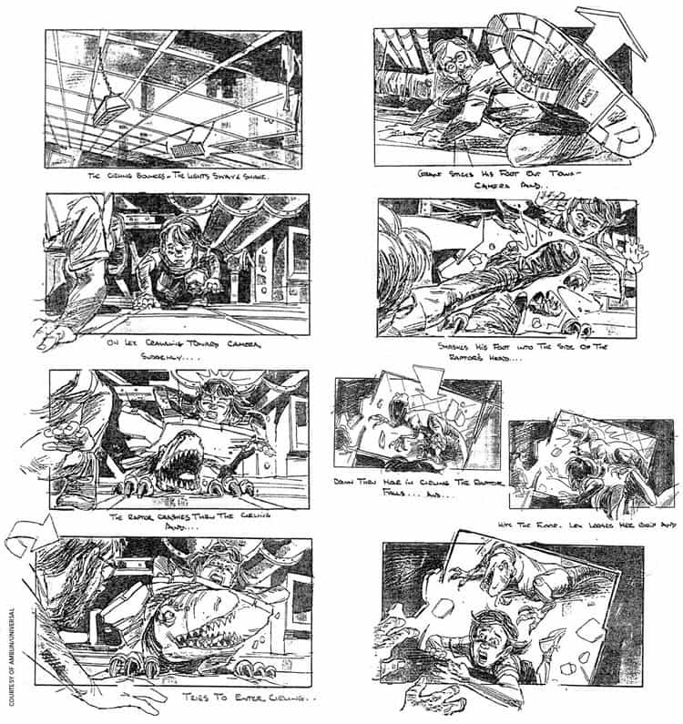

storyboard is a graphic layout that sequences illustrations and images with the purpose of visually telling a story. Filmmakers and video creators use storyboards to transfer ideas from thier mind to the screen. Creating an effective story board takes skill, but you can learn from storyboard examples to gain some pro tips.

Take a look at these fantastic professional storyboard examples. These verified storyboards were released by the DGA, and they include storyboard examples from Harry Potter, Star Wars, Inception, Gladiator, Jurassic Park, Moulin Rouge, and many other great films.

Storyboard Examples

- Sci-Fi Movie Storyboards
- Drama Movie Storyboards
- Musical Movie Storyboards
- Horror Movie Storyboards
- Fantasy Movie Storyboards
- Television Show Storyboards
- Animation Storyboards

